20111051 Jaewoo An

Lab #12: Live Cell Imaging and Probing

1. Results
   1. Live Cell Imaging edited with ImageJ:

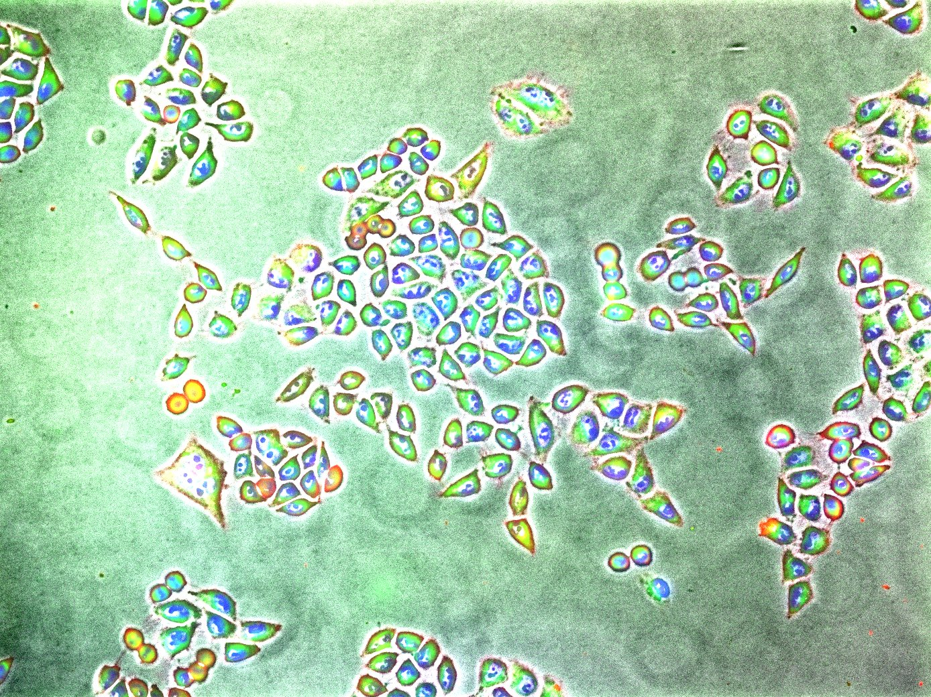

[Figure 1] Without CAPE (noCAPE3.zvi)

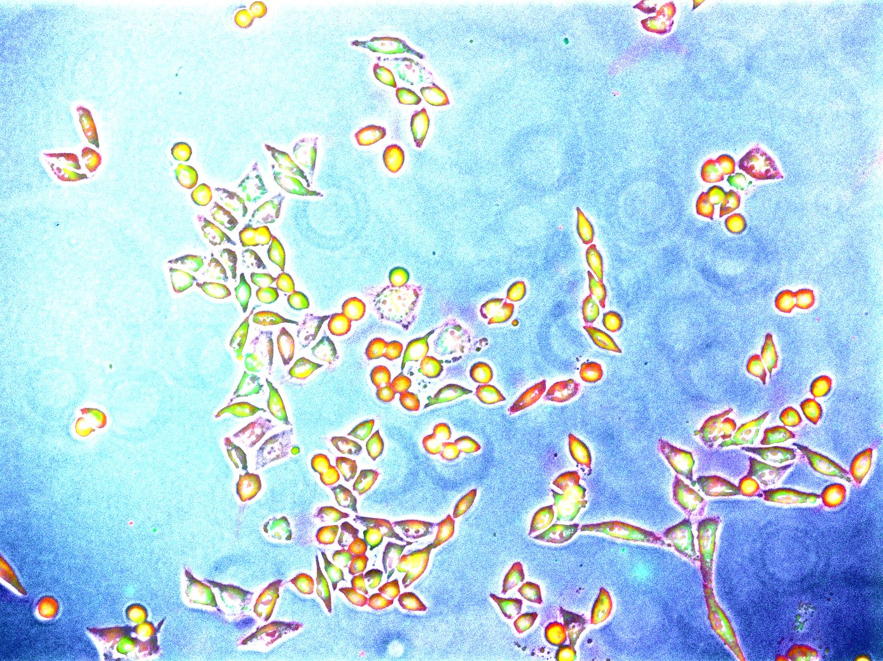

[Figure 2] With CAPE (CAPE4.zvi)

|  |  |  |  |  |
| --- | --- | --- | --- | --- |
|  | Red | Green | Blue | Gray |
| Channel | 4 | 5 | 6 | 1 |
| Fluorescence Dye | wga-594 | Mitotracker Green | Hoechst | Phase Microscopy |
| Target | Plasma membrane | Mitochondria | Nuclei |

* 1. Analyze the figure above in terms of physiology. (Morphologies of membrane, mitochondria and nucleus)

In Figure 1, live cells have thin red plasma membrane. Each cell is mostly composed of green mitochondria, and the rest – nucleus – is colored blue. The media is colored green due to technical limitations in adjusting the brightness and contrast of Channel5.

In Figure 2, which is mostly dead cells, the media is colored blue, because of the nuclei from the dead cells. The dead cells are circular in shape, are surrounded by red plasma membrane, and filled with yellow color. In optics, the color yellow is formed as the combination of red and green, implying that the plasma membrane and mitochondria are collapsed and mixed together.

* 1. Analyze TA’s supplement figure.

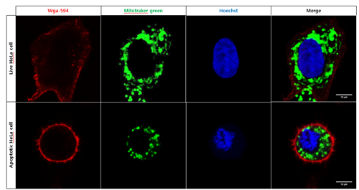

[Figure 3] TA’s Supplement Figure

Here, the only difference between the live HeLa cell and apoptotic HeLa cell is that the latter is circular and smaller in shape. Once HeLa cells enter apoptosis, they shrink in circular shape so the phagocytes can easily swallow them.

1. Discussion
   1. Explain the role of apoptosis in living organisms.

First of all, apoptosis takes place to get rid of excess cells such as those between the fingers and toes during the foetal period. Apoptosis also takes care of the nervous cells without functioning synapsis and even defective lymphocytes. Moreover, apoptosis commands activated T lymphocytes to kill themselves so that they will not attack the human body, causing autoimmune diseases. Killing bodily cells are not as bad as they sound. Since human bodies produce billions of cells every day, there has to be a way to discard billions of cells every day too. Apoptosis is the key to maintaining this homeostasis.

* 1. Describe the representative physiological changes of mammalian cells during apoptosis, and compare with your Results.

During the early stages of apoptosis, cells shrink and pyknosis–irreversible condensation of chromatin–take place. This is why the apoptotic cells were shaped round in my observations. In fact, the mammalian apoptotic cells appear round or oval with dark eosinophilic cytoplasm and dense purple nuclear chromatin fragments due to the pyknosis. In my results, some cells had purple areas around them, but most dead cells were yellow. It is likely that I made a mistake in adjusting the contrast/brightness of the figure.

* 1. Freely discuss other factors that you observed during the experiment.

During the experiment, I noticed some big blurry circular marks through the microscope. At that time I wondered what they were, but now I know what they were. They must have been the dead HeLa cells. Since the dead HeLa cells won’t stick to the dish as the live cells do, they appeared to be big (floating on the media, and therefore closer to the microscope). Their circular shapes can also be explained, because HeLa cells shrink in circular shape once they enter the state of apoptosis. The dead HeLa cells would not have been observed much if we had enough time to wash the dish off the dead cells.